AWS EC2 and S3 Use Case

Kevin Litchmore

**Agenda:**

Use the AWS EC2 and S3 features to facilitate data migration in a production environment between the business, data engineer and data analyst.

**Assumptions:**

1. The Data Engineer will access the bucket using the Linux OS instance.
2. The Data Analyst will access the bucket using the Windows OS instance.
3. Direct bucket access will be used to facilitate the data that is already present on behalf of the business via “host computer”.
4. The host computer will also be used to verify functionality for the Data Analyst since both use the same operating system.

Step 1: Ensure all instances are running

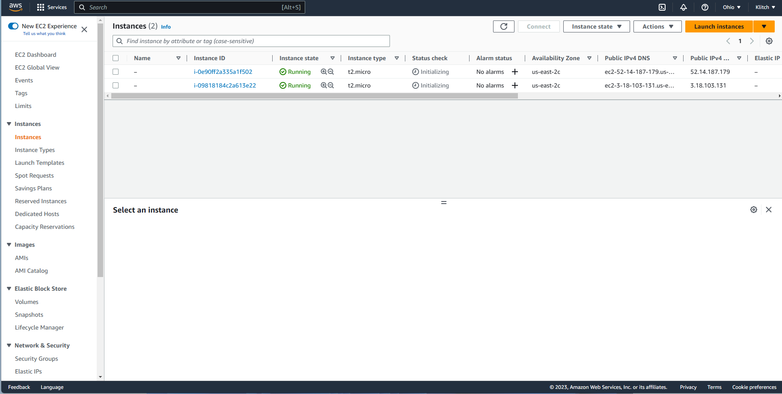

Step 2: Connect to Linux Instance: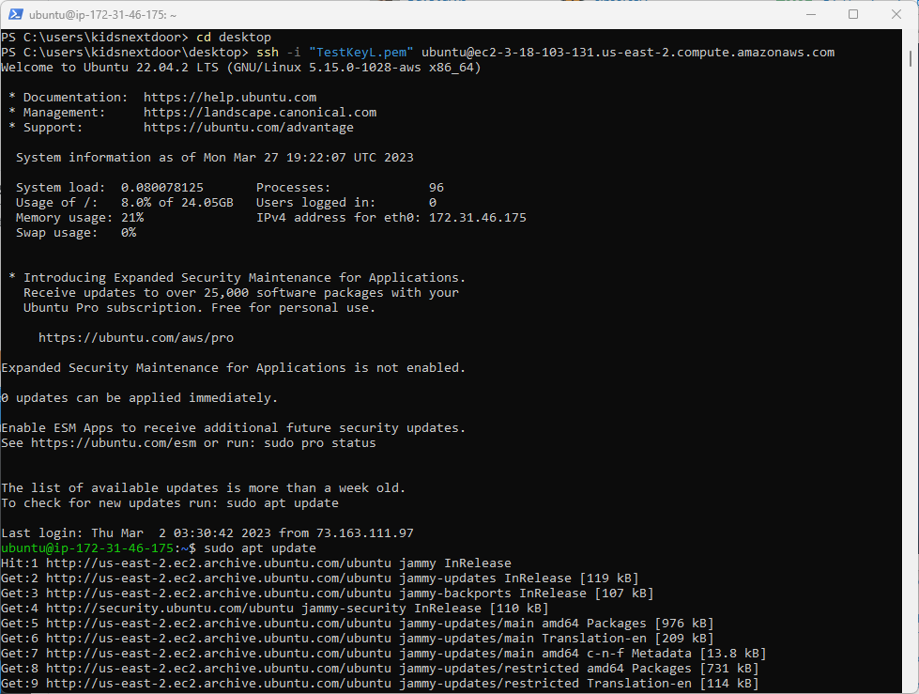

Step 3: Connect to your Windows Instance:

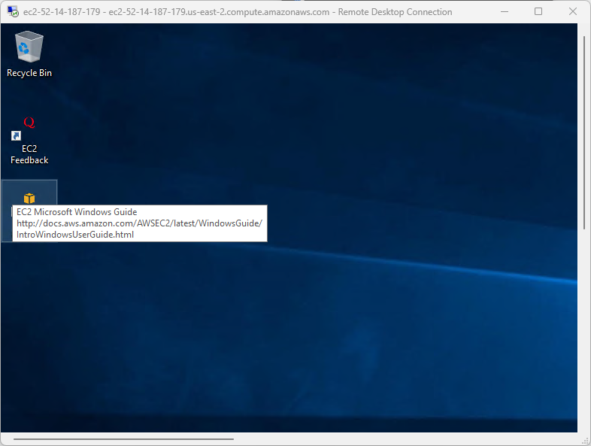

Step 4: Verify creation of S3 Bucket

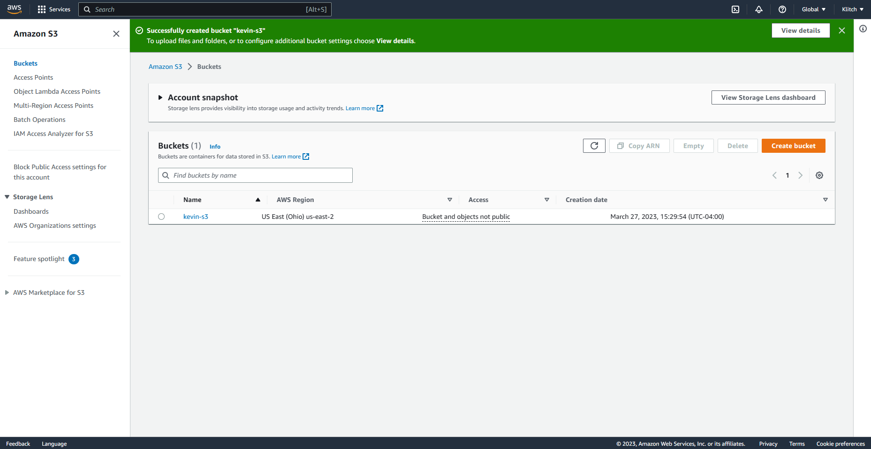

Step 5a: Verify data file on host computer:



Step 5b: Upload data file on S3 bucket from host computer:

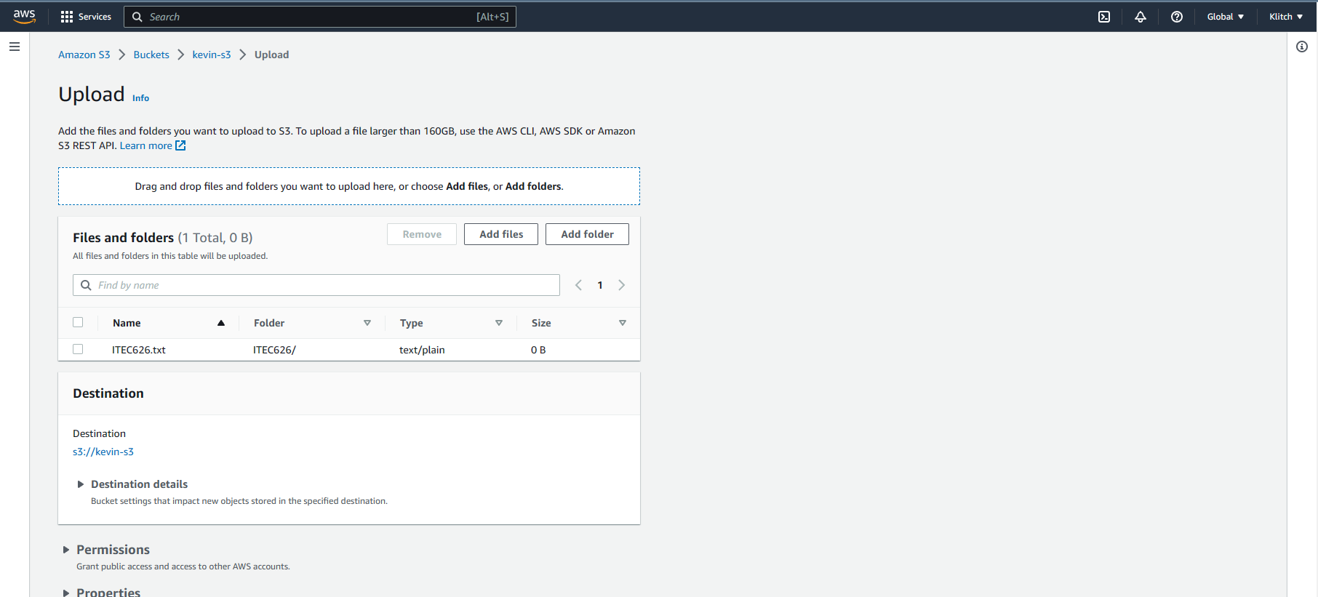

Step 5c: Successful upload to S3 bucket:

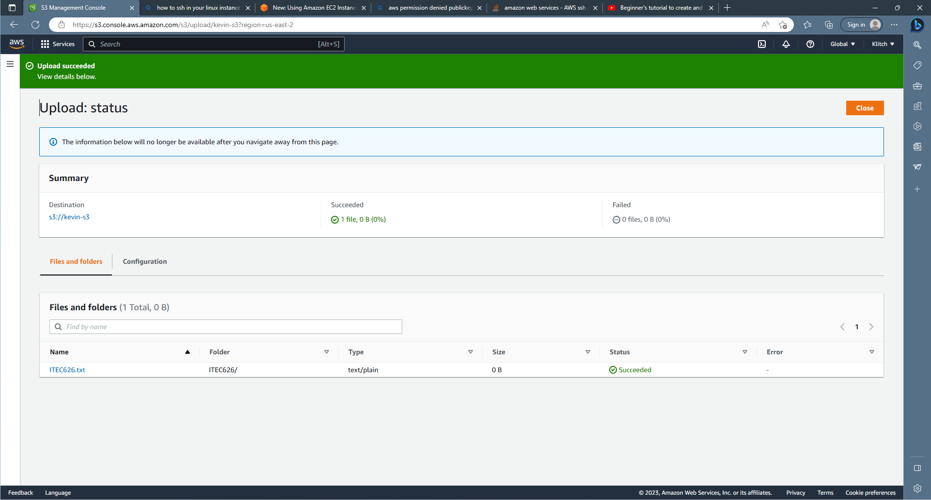

Step 7: Successful download from S3 bucket to host computer:

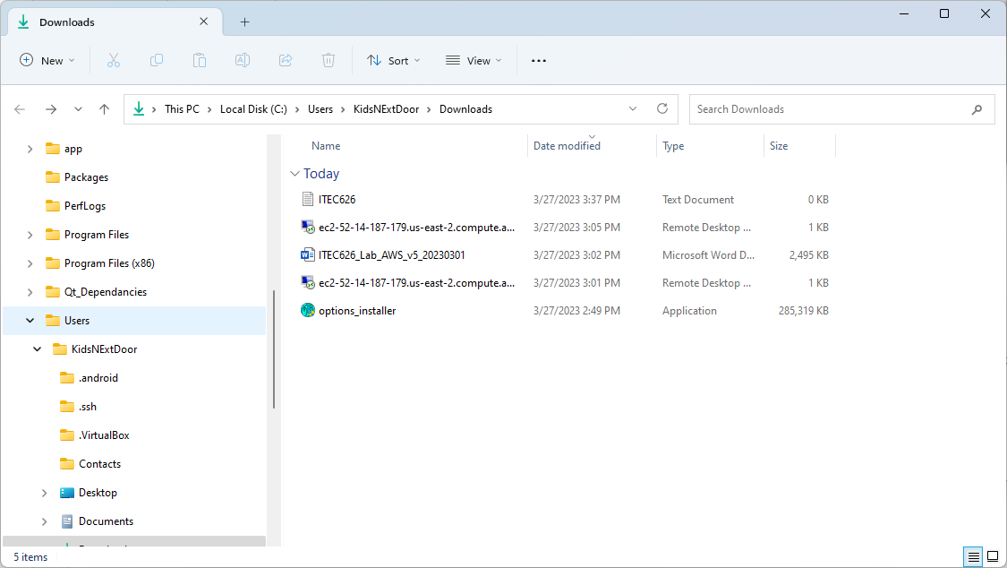

Step 8: Successful data file upload to instance:

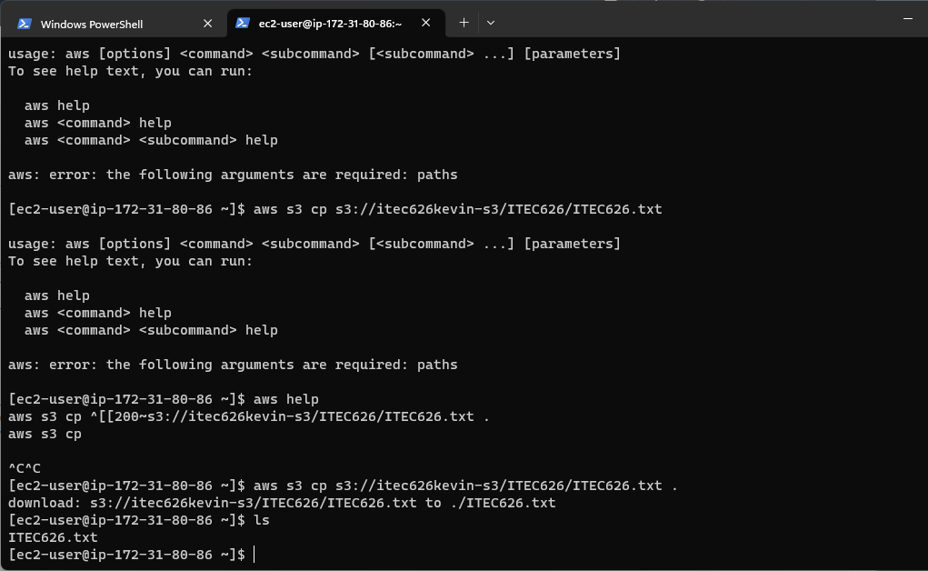

Step 9: Successful download from instance to S3 bucket (file renamed to shows data file difference):

